**What Is the D3 *Library*?**

The D3 *library* is a JavaScript *library* used for visualization. The goal of D3 is to associate the data you want to visualize with the DOM. This allows you to directly manipulate, change, or add to the DOM, thus enabling greater control over how the web page will appear.

D3 can be used in many ways. An extensive list can be found on the [D3 Gallery](https://observablehq.com/@d3/gallery)

[Links to an external site.](https://observablehq.com/@d3/gallery)

page. In this mini-lesson, you will learn how to create a bubble chart to display word frequencies.

**How to Create a Bubble Chart Using D3**

To follow along with this mini-lesson, download the [d3_bubble_chart_example.html](https://classroom.emeritus.org/courses/10605/files/3007498/download) file, which contains the code to create a bubble chart to display word frequency using the D3 *library*.

After downloading the file, open it using VS Code. The steps below will guide you through the code in the index.html file.

The code below demonstrates how to import the JavaScript D3 *library* into your HTML file. This will allow you to use the *library* without installing it locally. Next, you will manually define a dataset named children. This dataset is an *array* that contains each word and how many times it occurs in your data. In the example below, only four words are defined: Olivia, Mark, Jessica, and Alex.

<!DOCTYPE html>

<html lang="en">

<head>

<meta charset="utf-8">

<script

type="text/javascript"src="https://d3js.org/d3.v4.min.js">

</script>

<style type="text/css">

</style>

</head>

<body>

<script type="text/javascript">

dataset = {

"children": [{"Name":"Olivia","Count":78},

{"Name":"Mark","Count":35},

{"Name":"Jessica","Count":30},

{"Name":"Alex","Count":55}]

};

Next, define the bubbles for the diagram on your HTML page. You can do this by calling the append()*function* and bypassing circles as *arguments*. This is demonstrated in the code below:

node.append("circle")

.attr("r", function(d) {return d.r;})

.style("fill", function(d,i) {return color(i);});

Next, you can add the information about your words to your HTML code to display each word and its frequency. The code below uses the append()*function* with text as an *argument* to enhance your bubble diagram by adding labels to the circles. This *function* reads the name of every word in your dataset and adjusts the font to scale along with the size of the corresponding bubble.

node.append("text")

.attr("dy", ".2em")

.style("text-anchor", "middle")

.text(function(d) {

return d.data.Name.substring(0, d.r / 3);})

.attr("font-family", "sans-serif")

.attr("font-size", function(d){

return d.r/5;})

.attr("fill", "white");

Finally, the frequency of each word is added by calling the append()*function* with text as an *argument* once again. This time, this *function* enhances your bubble diagram by retrieving the number of times each word appears in the dataset. It then adjusts the font for the frequency count to be at scale with the corresponding bubble.

node.append("text")

.attr("dy", "1.3em")

.style("text-anchor", "middle")

.text(function(d) {

return d.data.Count;})

.attr("font-family", "Gill Sans", "Gill Sans MT")

.attr("font-size", function(d){

return d.r/5;})

.attr("fill", "white");

To experiment with this code, open a new browser window and navigate to the following URL:

file:///YOUR_PATH_HERE/d3_bubble_chart_example.html

You should see the following bubble chart:

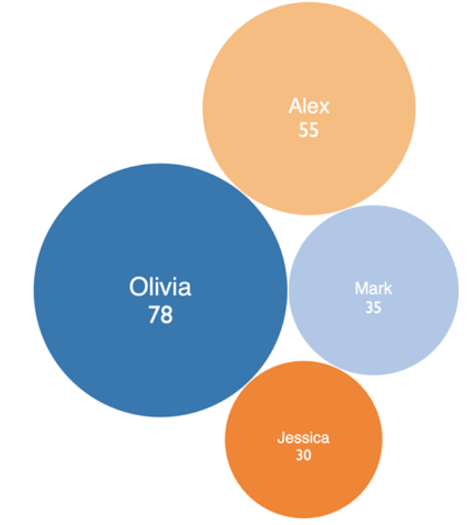Now you know how to create a bubble chart using the D3 *library*.

**Project 23.1 Connections**

In the final project for this module, you will be asked to enhance the provided data visualization code to create a bubble chart using the D3 *library.* In particular, you will be asked to create a bubble chart that displays the words and the frequency of those words in the course titles in the MIT course catalog. You can use and adapt the code in the d3_bubble_chart_example.html file to achieve the desired result.

As a future data engineer, learning to use the D3 *library* is important. D3 is arguably the most comprehensive JavaScript *library* for data visualization, as it offers a wide range of *functions* that will allow you to create any type of visualization that you need.